Apply Your Knowledge
1. Predict the Result.
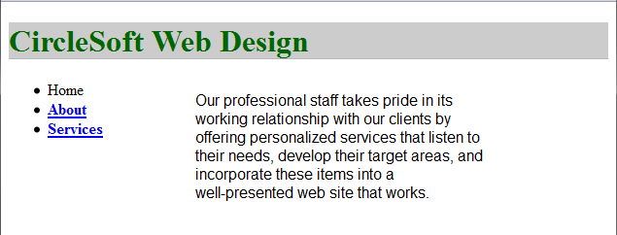
2. Fill in the Missing Code.
A suggested solution is shown below.
<!DOCTYPE html>
<html lang="en">
<head>
<title>Trillium Media Design</title>
<meta charset="utf-8"><style type="text/css">
nav { float: right;
width: 150px;
height: 300px;
background-color: #cccccc;
border: 1px solid #000000; }
header { background-color: #cccccc;
color: #663333;
font-size: x-large;
border-bottom: 1px solid #333333; }
main { margin-right: 160px; }
footer { font-size: x-small;
text-align: center;
clear: both; }
nav a { color: #000066;
text-decoration: none; }
ul {list-style-type: none; }
</style>
</head>
<body>
<nav>
<ul>
<li><a href="index.html">Home</a></li>
<li><a href="products.html">Products</a></li>
<li><a href="services.html">Services</a></li>
<li><a href="about.html">About</a></li>
</ul>
</nav>
<main>
<header>
<h1>Trillium Media Design</h1>
</header>
<p>Our professional staff takes pride in its working relationship with our clients by offering personalized services that listen to their needs, develop their target areas, and incorporate these items into a well-presented website that works.</p>
</main>
<footer>
Copyright &copy; 2014 Trillium Media Design<br>
Last Updated on 06/03/14
</footer>
</body>
</html>

3. Find the Error.
Student answers will vary. Debugging methods discussed in the chapter should be referenced. The most straightforward solution is to remove the absolution positioning from the h1 selector.
Hands-On Exercises
- #floating {float :left; background-color: #ffffcc; font-family: Verdana,sans-serif;font-size: large;padding: 20px; }
- .headline { background-color: #eaeaea; color: #336600; text-transform: uppercase; border-bottom: 2px dotted #336600; }
- #myid {position: absolute; top: 20px; right :40px; background-color: #cccccc; border: 1px solid #000000; }
- .myclass { position: relative; left: 15px; background-color: #ccff99; }
- #myid { position: fixed; background-color: #eaeaea; font-weight: bold; padding: 10px; }
- ul { list-style-image: url(myimage.gif);
- ul {list-style-type: square; }
- Student answers will vary.
- Student answers will vary.
- Student answers will vary.
Web Research
Your students’ answers should vary as they find different CSS resources. Each student should create a web page that describes five CSS resources. The page should use absolute positioning.
Focus on Web Design
Your students’ answers should vary. Students will each find various CSS page layout tutorials that focus on a technique that was not discussed in the chapter and create a Web page that uses this technique.

